|  |  |
| --- | --- |
| Nikon Z 85mm f/1.8 S lens  Ống kính Nikon Z 85mm f/1.8 S  Ống kính Nikon NIKKOR Z 85mm f1.8 S-1 Ống kính Nikon NIKKOR Z 85mm f1.8 S-2 Ống kính Nikon NIKKOR Z 85mm f1.8 S Ống kính Nikon NIKKOR Z 85mm f1.8 S-4 | **Featured information:**  Nano Crystal Technology & Super Integrated Coatings  Focus quickly and accurately  Aperture range: f/1.8 to f/16  Compatible with Z mount / FX format lenses  Price : $ 700  **Specifications:**  Focal distance  85mm  Largest Aperture  f/1.8  Smallest Aperture  f/16  Lens Mount  Nikon Z  Lens Format  Full-Frame  View  28° 30'  Minimum Focus Distance  2.62' / 80 cm  Magnification  0.12x  Optical Components  12 lenses in 8 groups  Number of Mouth Blades  9  Focus Type  Autofocus  Anti-Vibration |

**Overview:**

The Nikon Z 85mm f/1.8 S is a short telephoto lens for portrait photography. The lens is constructed with two extra-low dispersion elements that help reduce color fringing and chromatic aberrations ensuring high clarity and color fidelity. In addition, Nano Crystal technology and Super Integrated Coatings are also used to prevent flare and ghosting, providing images with more realistic colors and higher contrast.

The lens is designed specifically for FX-format Z-mount mirrorless cameras. With a maximum aperture of f/1.8, the lens is able to operate effectively in low light conditions, helping to obtain bright and sharp images even when shooting in low light environments. At the same time, this aperture level also provides better control over depth of field, helping to capture more impressive background images.

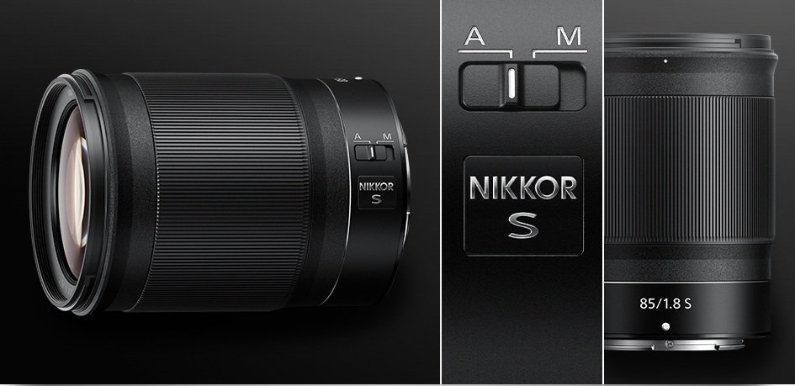

The lens has an optical design consisting of 12 elements divided into 8 groups, including two ultra-low dispersion elements that help reduce chromatic aberrations and color fringing, while increasing color contrast for images. The images obtained behind the lens are more vivid and have higher fidelity.

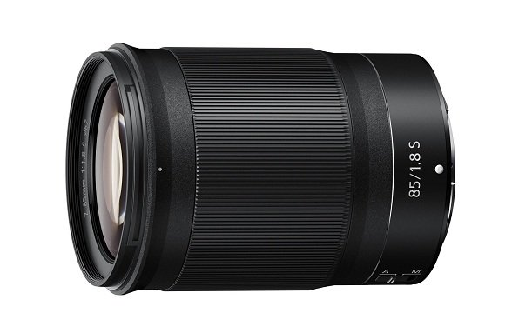

The Nikon Z 85mm f/1.8 S lens incorporates an electromagnetic aperture mechanism for highly precise aperture control, while also providing more stable automatic exposure control when shooting fast-moving scenes or in complex lighting environments.

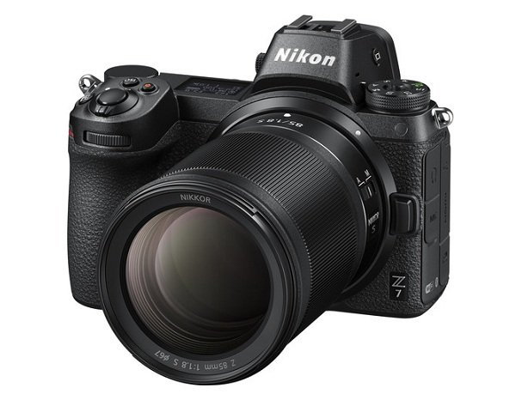

Similar to its lens products, Nikon also included this lens with dust-proof and moisture-proof features to help users comfortably use and preserve the lens in harsh conditions.

The diaphragm consists of 9 rounded blades and a maximum aperture of f/1.8, providing beautiful bokeh quality and shallow depth of field.

